### Project Name: Sales Automobile Using Salesforce CRM

Team ID: LTVIP2024TMID11576

Team Leader: V Shilpa

Team member: R Likitha

### The Lightning App

### Create A Lightning App

1. Go to setup page  >>  search “app manager” in quick find >>  select “app manager”  >> click on New lightning App.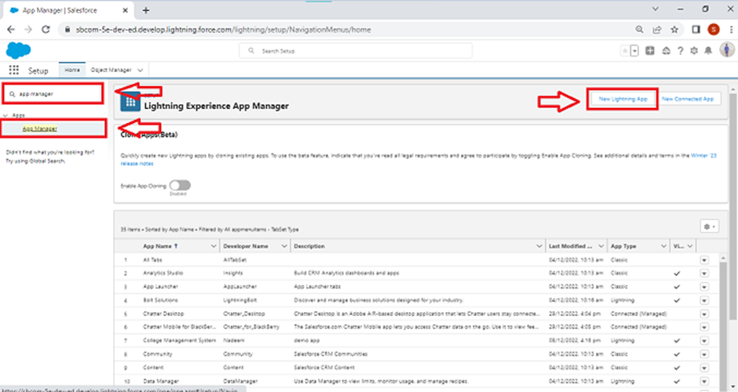
2. Fill the app name in app details and branding as follow
   1. App Name :Sales Automobile Using Salesforce CRM
   2. Developer Name : this will auto populated
   3. Description : Give a meaningful description
   4. Image : optional (if you want to give any image you can otherwise not mandatory)
   5. Primary color hex value : keep this default
3. Then click Next  >>  (App option page) keep it as default >> Next  >> (Utility Items) keep it as default >> Next.  
   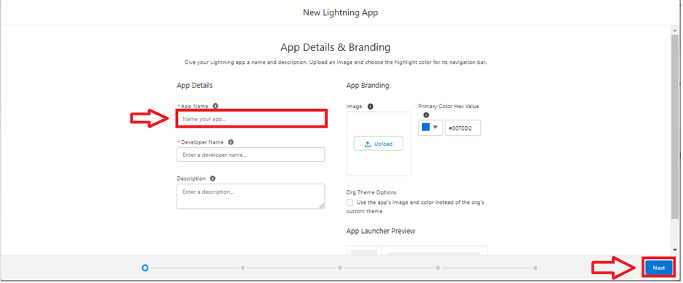
4. Add Navigation Items:  
     
   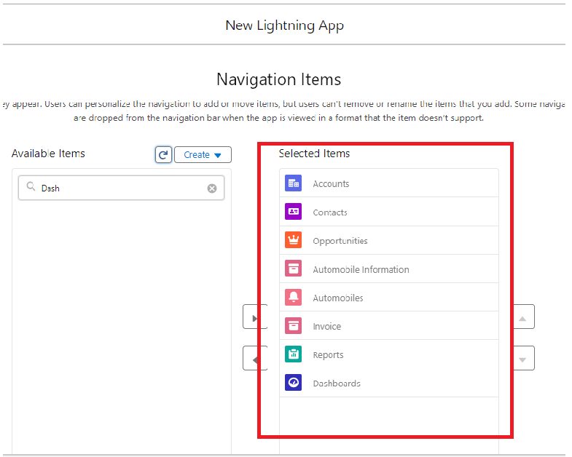
5. Search the items in the search bar(Account,Contact ,Opportunities,Automobile Information,Opportunity Automobile,Invoice, Reports, Dashboard) from the search bar and move it using the arrow button ? Next.  
   Note: select asset the custom object which we have created in the previous activity.

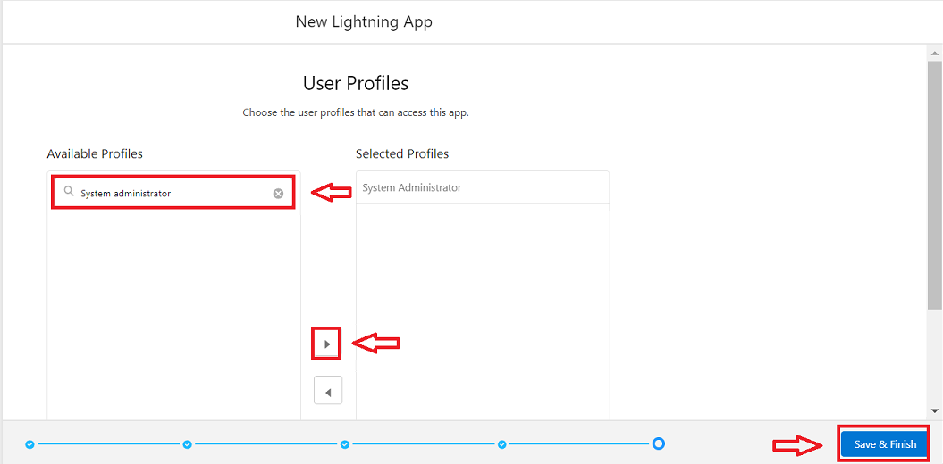

1. Search profiles (System administrator) in the search bar >>  click on the arrow button >> save & finish.

### Fields & Relationships

**Creating Opportunity Master Detail Relationship Field In Opportunity AutoMobile Object**

To create fields in an object:

1. Go to setup >> click on Object Manager >>  type object name(Opportunity Automobile) in quick find bar>>  click on the object. 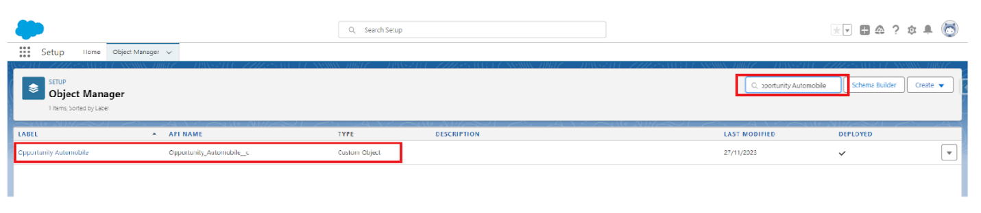
2. Now click on “Fields & Relationships” >> New

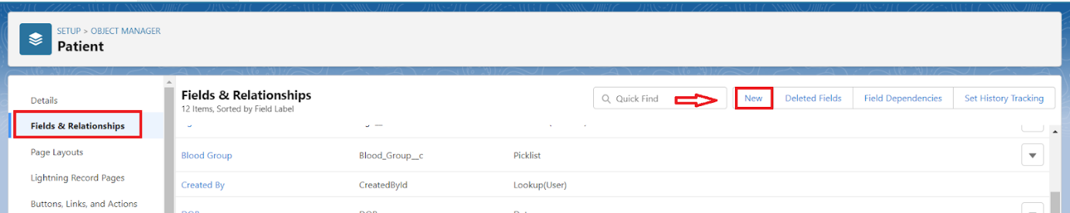

1. Select Data type as “Master Details Relationship”.

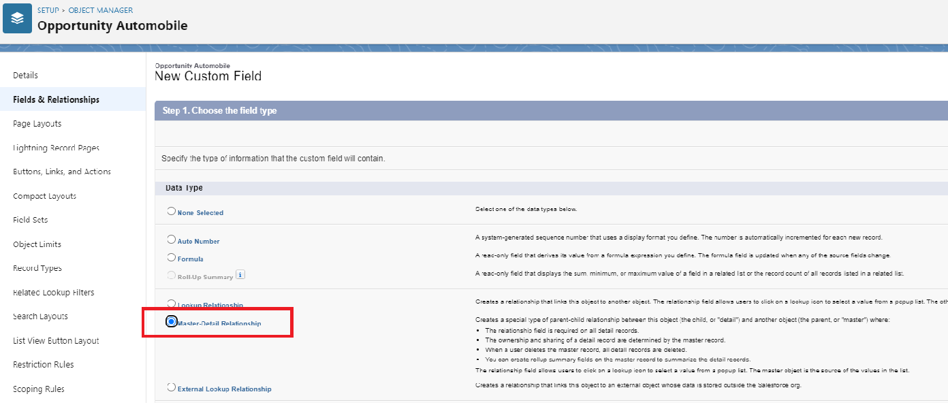

1. Click on Next

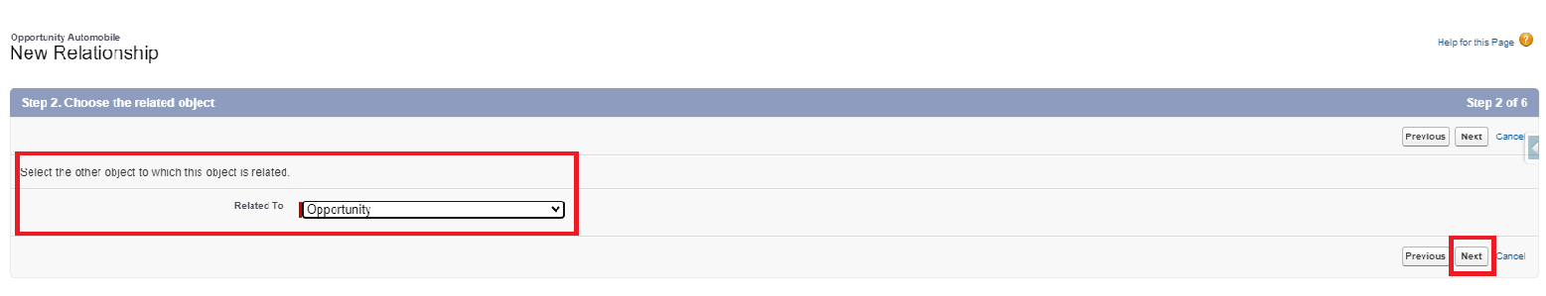

1. Fill the above as following:

* Field Label: gets auto Generated(Opportunity)
* Field Name : gets auto generated(Opportunity)
* Click on Next >>  Next >>  Save and new.

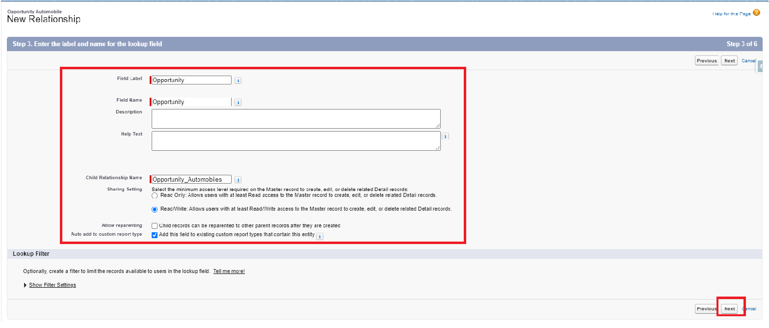

### Creating The AutoMobile Information Lookup Field In Opportunity Automobile Object

To create fields in an object:

1. Go to setup >> click on Object Manager >>  type object name(Opportunity Automobile) in quick find bar>>  click on the object. 
2. Now click on “Fields & Relationships” >> New  
   
3. Select Data type as “Lookup RelationShip”.  
   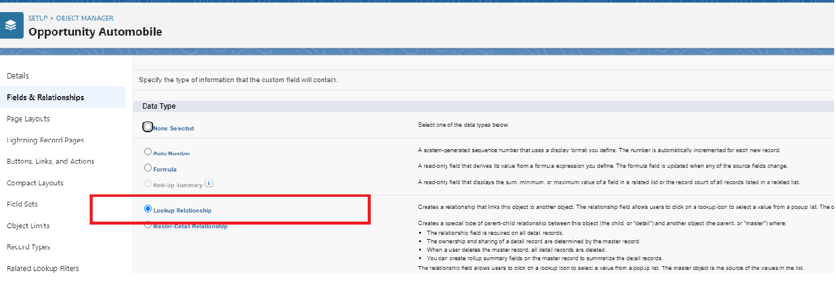
4. Click on Next  
   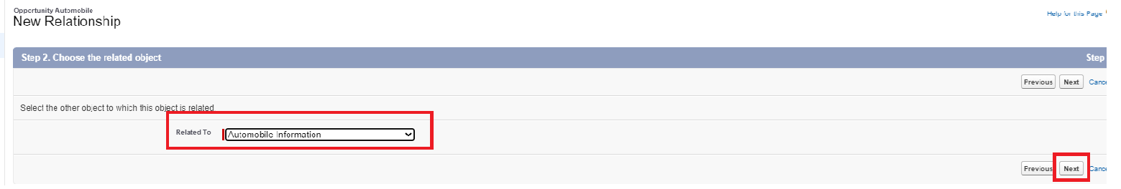
5. Fill the above as following:
   1. Field Label: Automobile
   2. Field Name : Automobile
6. Click on Next >>  Next>>  Save and new.  
   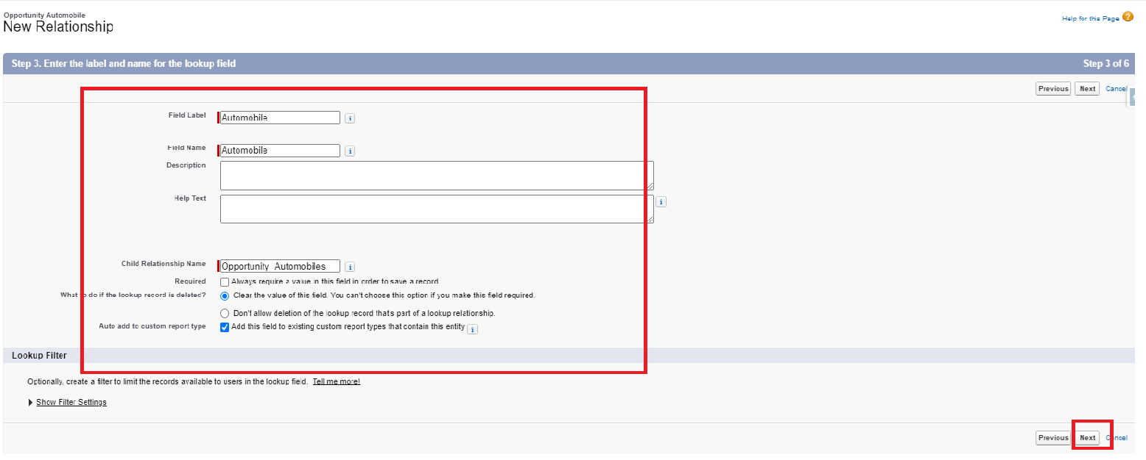

### Creating The AutoMobile Information Lookup Field In Opportunity Automobile Object

To create fields in an object:

1. Go to setup >> click on Object Manager >>  type object name(Opportunity Automobile) in quick find bar>>  click on the object. 
2. Now click on “Fields & Relationships” >> New  
   
3. Select Data type as “Lookup RelationShip”.  
   
4. Click on Next  
   
5. Fill the above as following:
   1. Field Label: Automobile
   2. Field Name : Automobile
6. Click on Next >>  Next>>  Save and new.  
   

**Creating Formula Field In Opportunity Automobile Object**

To create fields in an object:

1. Go to setup >> click on Object Manager >>  type object name(Opportunity Automobile) in quick find bar >> click on the object.

1. Now click on “Fields & Relationships” >>  New.
2. Select Data type as “Formula” and click Next.
3. Give Field Label and Field Name as “Unit Price” and select formula return type as “Currency” and change the decimal values to two and click next.

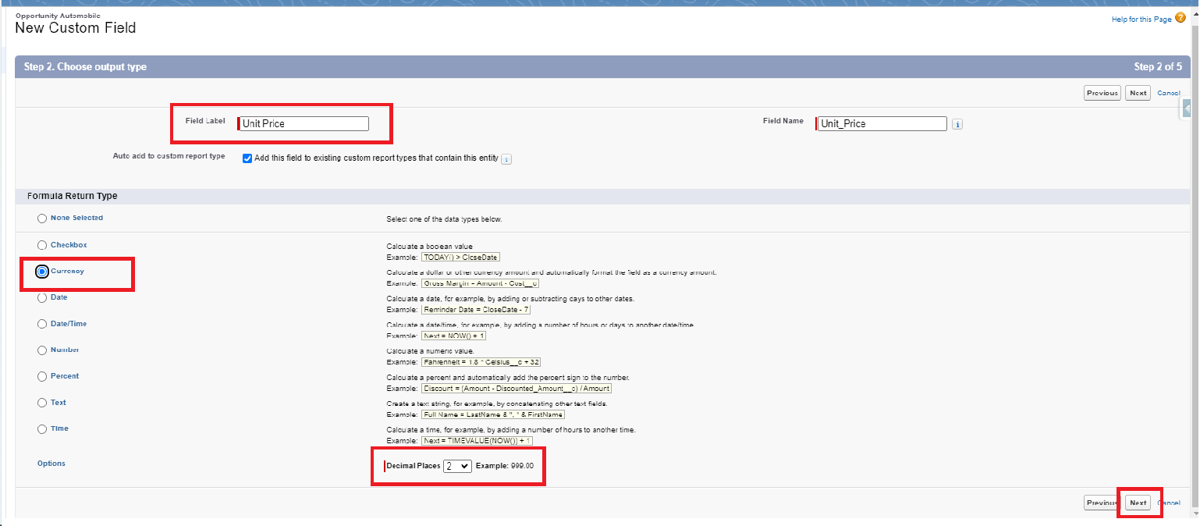

1. Under Advanced Formula write down the formula : Automobile__r.Price__c

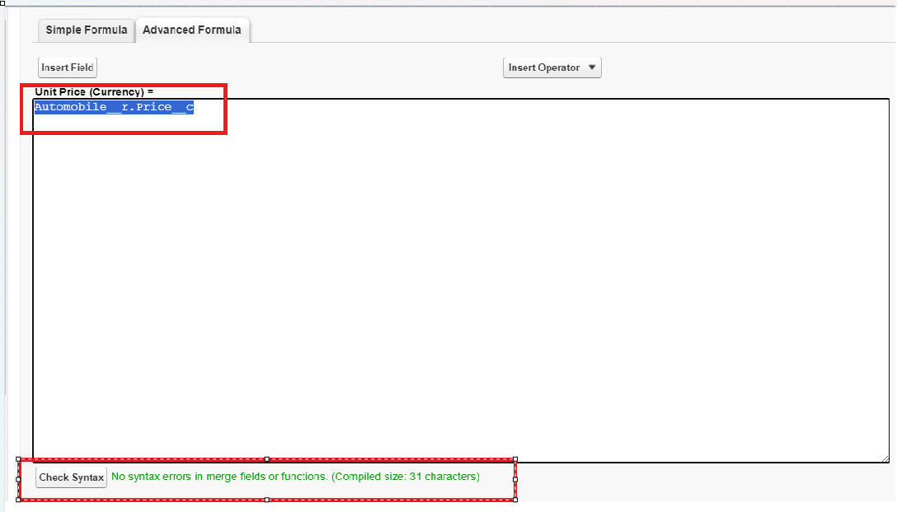

1. click “Check Syntax” and Next >> Next >> Save & New.

**Creating The Formula Field In Opportunity Automobile Object**

To create fields in an object:

1. Go to setup >> click on Object Manager >> type object name(Opportunity Automobile) in quick find bar >> click on the object.

1. Now click on “Fields & Relationships” >> New.
2. Select Data type as “Formula” and click Next.
3. Give Field Label and Field Name as “Total Price” and select formula return type as “Currency” and change the decimal values to two and click next.

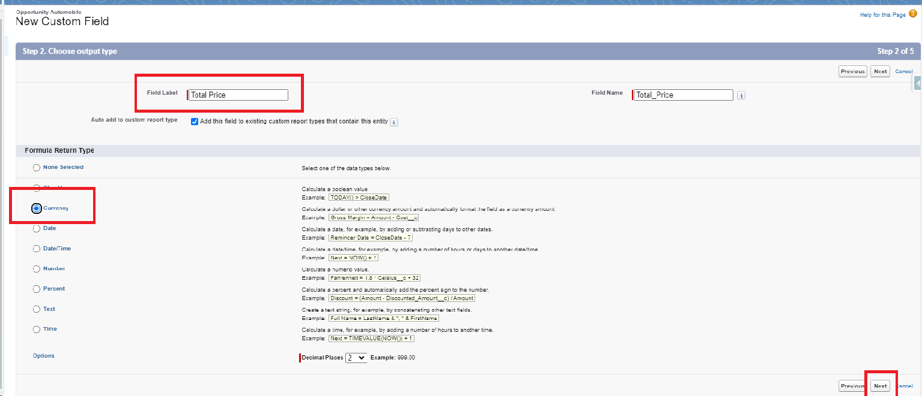

1. Under Advanced Formula write down the formula : Unit_Price__c  *  Quantity__c

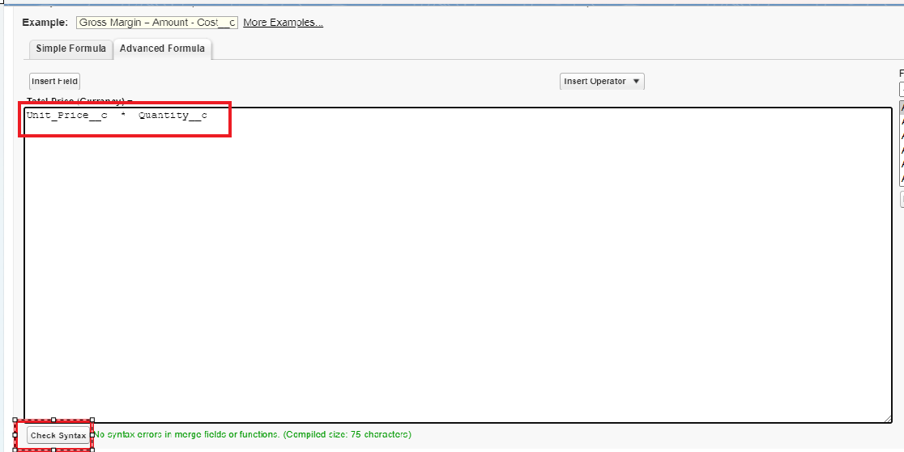

1. click “Check Syntax” and Next >> Next >> Save.

### Updating Field In Invoice Object

To Update fields in an object:

1. Go to setup ? click on Object Manager ? type object name(Invoice) in quick find bar? click on the object.
2. Now click on “Fields & Relationships” , Click on the edit of  Invoice Id field.  
   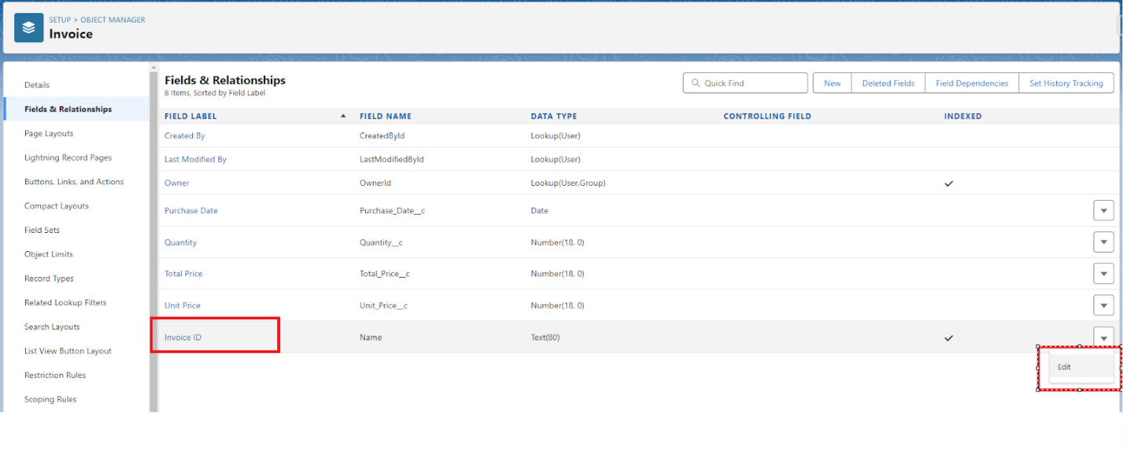  
   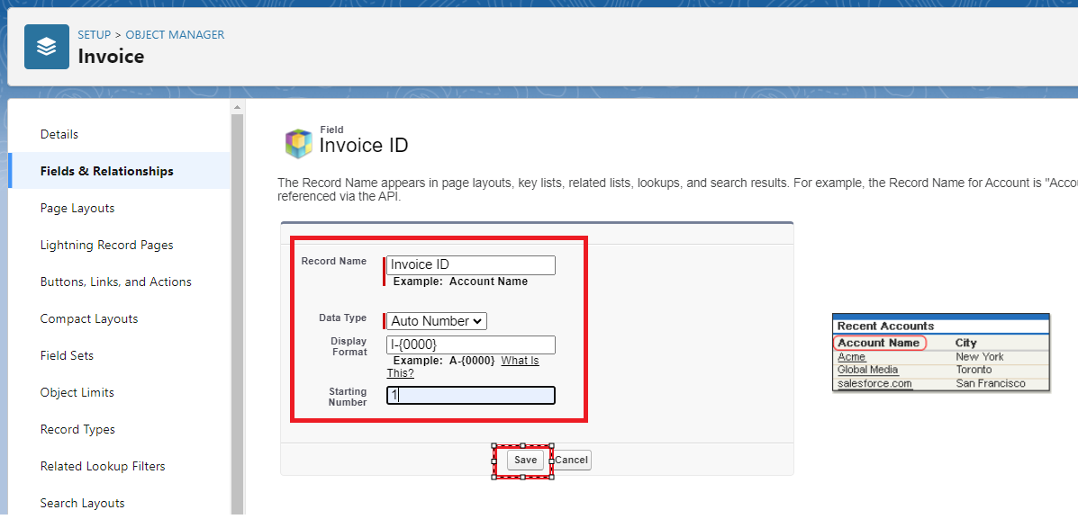
3. Select Data type as “Auto Number ” and click Next.
   1. Display Format :- I-{0000}
   2. StartingNumber:-
4. Click Save.
5. **Creating Remaining Fields In Objects**
6. Now create the remaining fields using the data types mentioned.

|  |  |  |
| --- | --- | --- |
| **s.no** | **Object name** | **Fields** |
| **1** | **Invoice** | |  |  | | --- | --- | | **Field Name** | Opportunity | | **Data type** | Master Detail relationship              Object : Opportunity | |

### Page Layouts

**Edit The Page Layout For Opportunity Object**

Step 1: Go to Setup >> Click on Object Manager >> On the search bar, select Opportunity Layout. You can notice Page Layouts on the left panel

Step 2: Click on Page Layouts, Click on ‘Opportunity Layouts’.

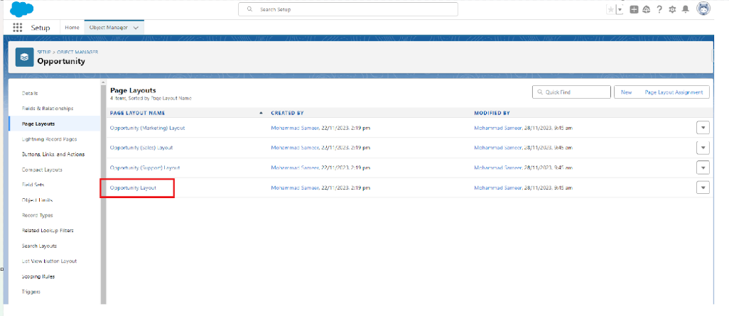

Step 3: In the Opportunity Detail Section, you can see various fields. Go on Account And Click on that Properties icon of Account name Field.

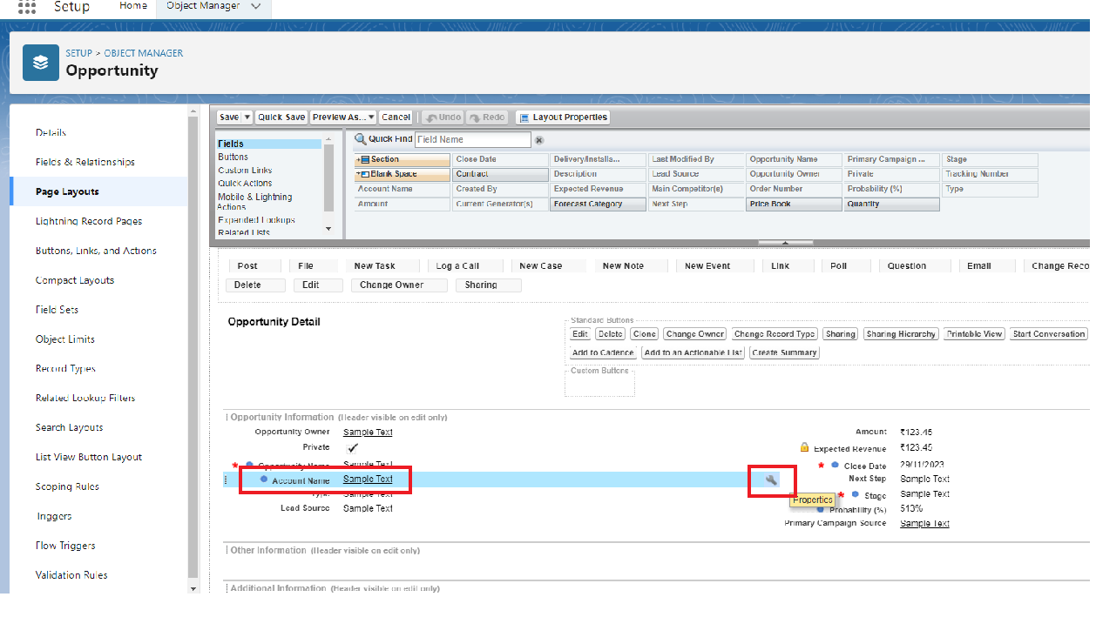

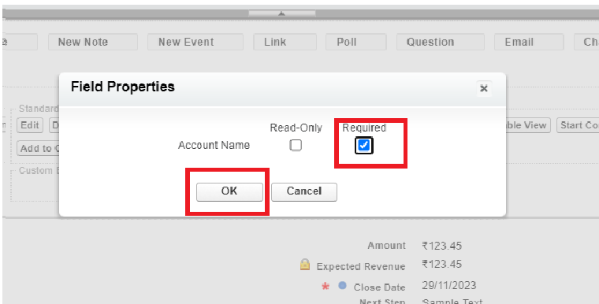

Step 4: check the Required box for Account name and click on Ok.

Step 5: Click on Save.

### Edit The Page Layout For Automobiles Information

Step 1: Go to Setup >> Click on Object Manager >> On the search bar, select Automobile Information. You can notice Page Layouts on the left panel

Step 2: Click on Page Layouts. Click on ‘Automobile Information Layout’.

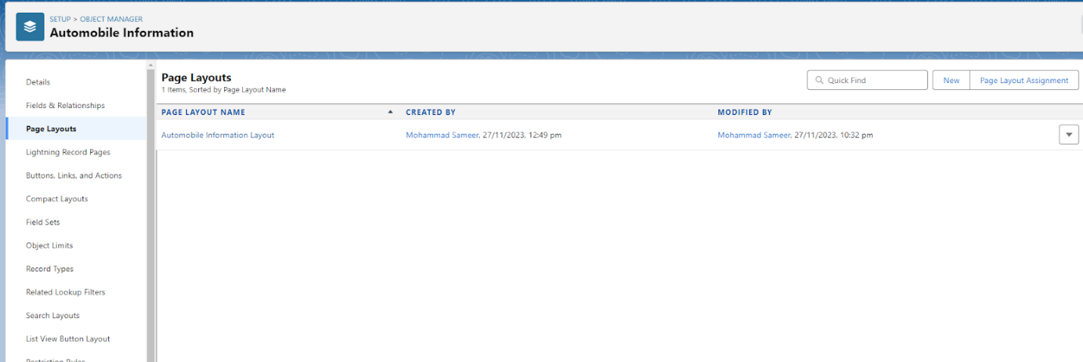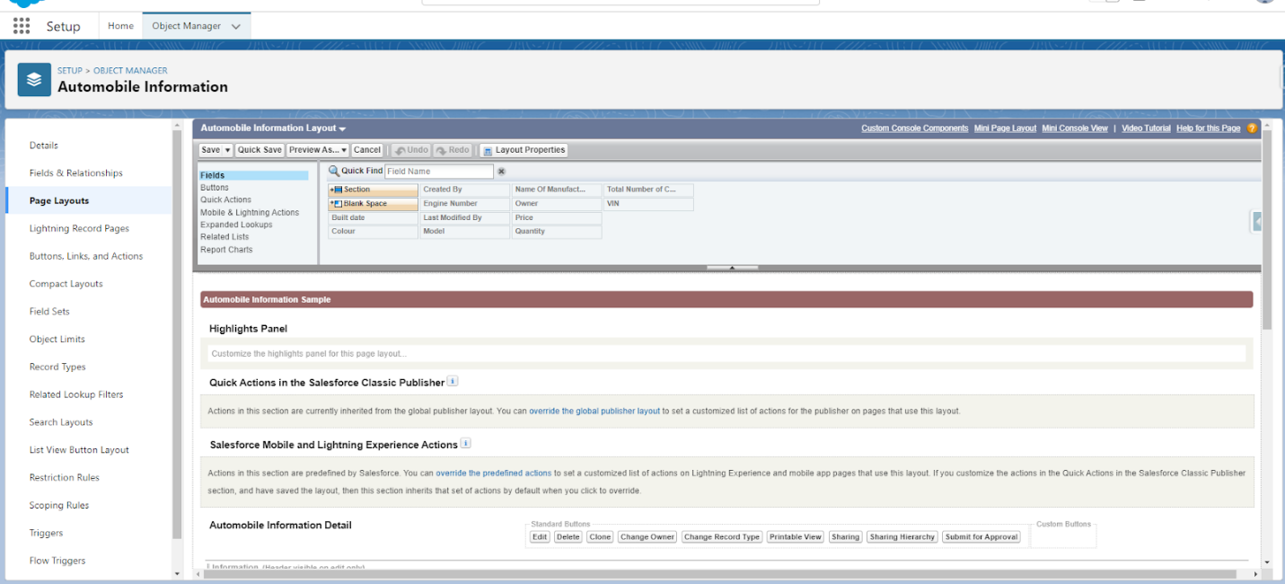

Step 3: Just Go for each one field of Automobile Information Object, Click on Gear Icon and mark as Required just as Done for Above Account Object. After required is done it will show the red color as given in below image.

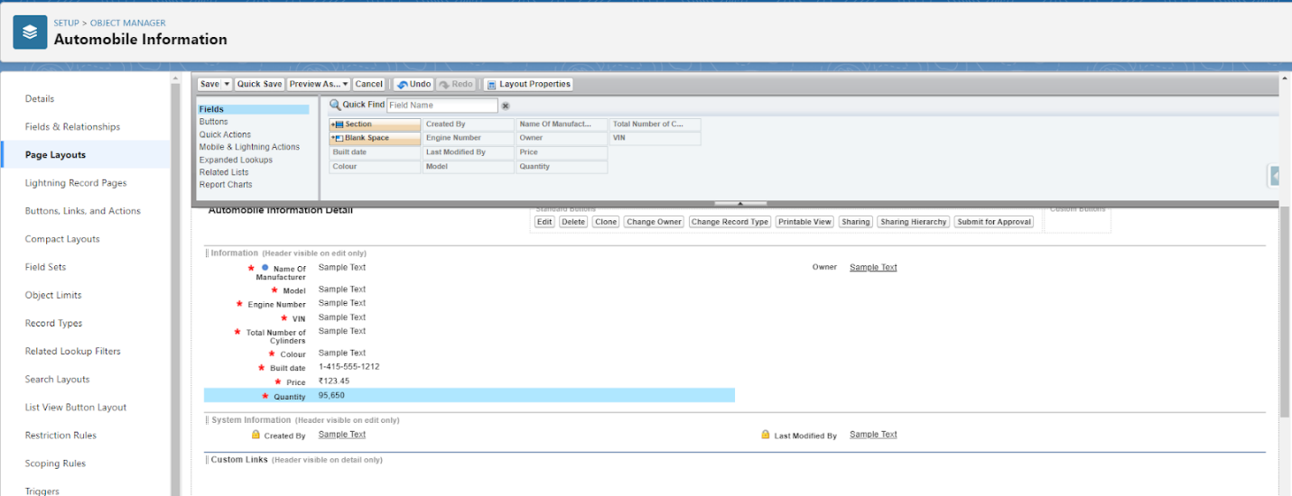

Step 4 : Adjust the Fields as given below for A good looking view.

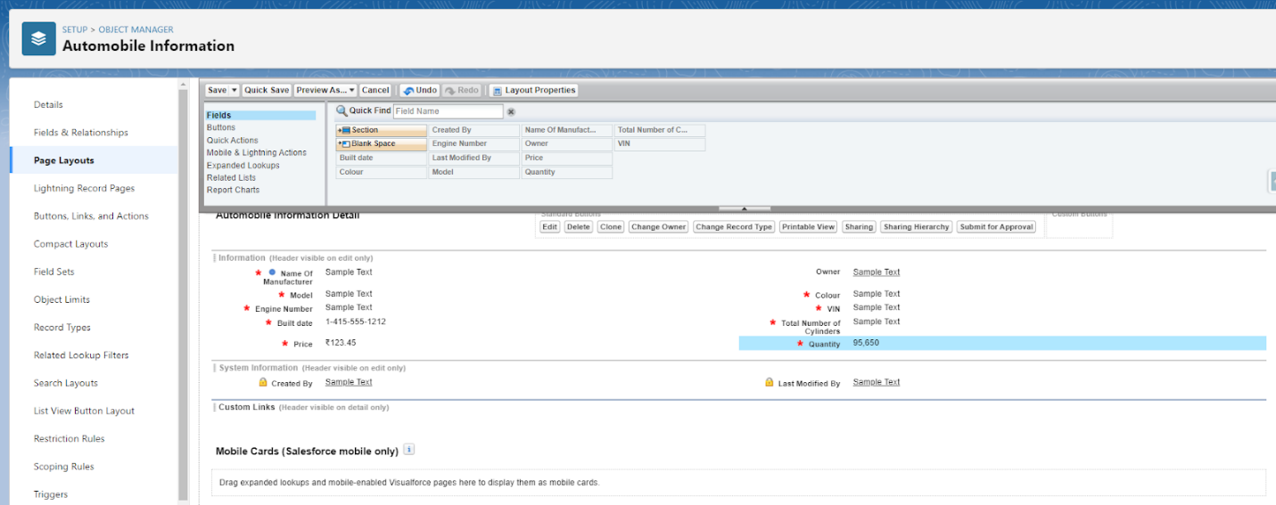

Step 5 : Click on Save.